EXPERIMENT – 11

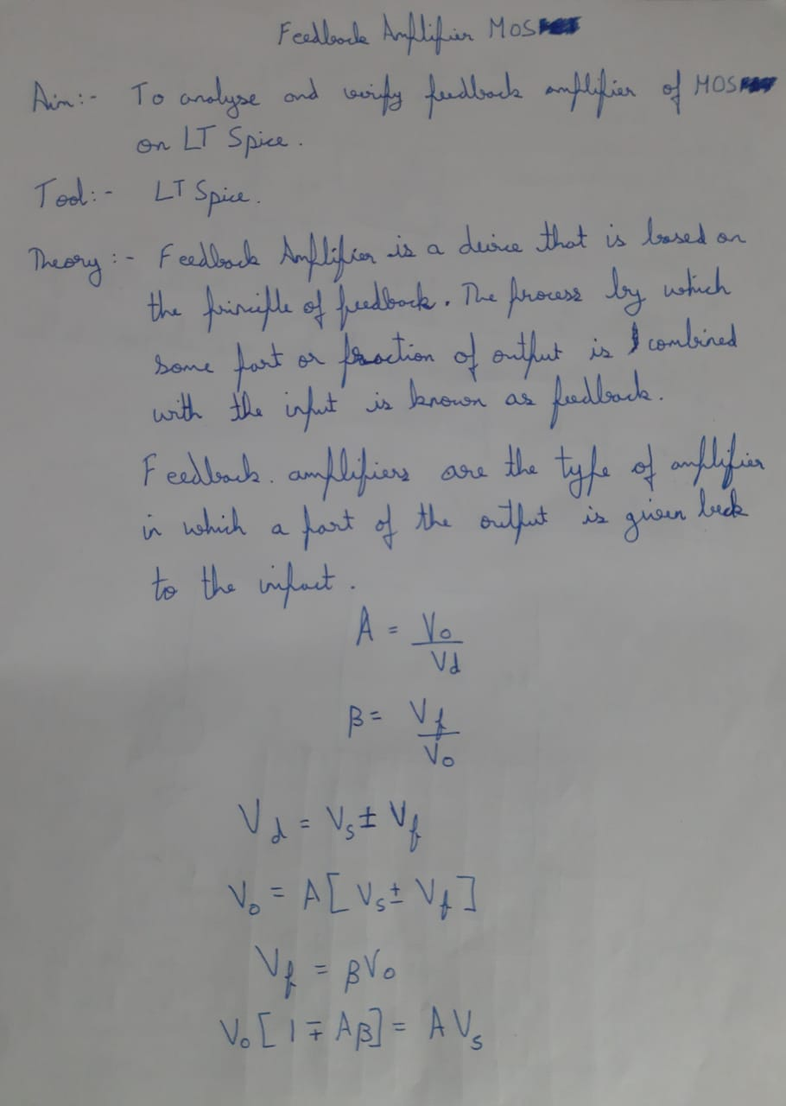

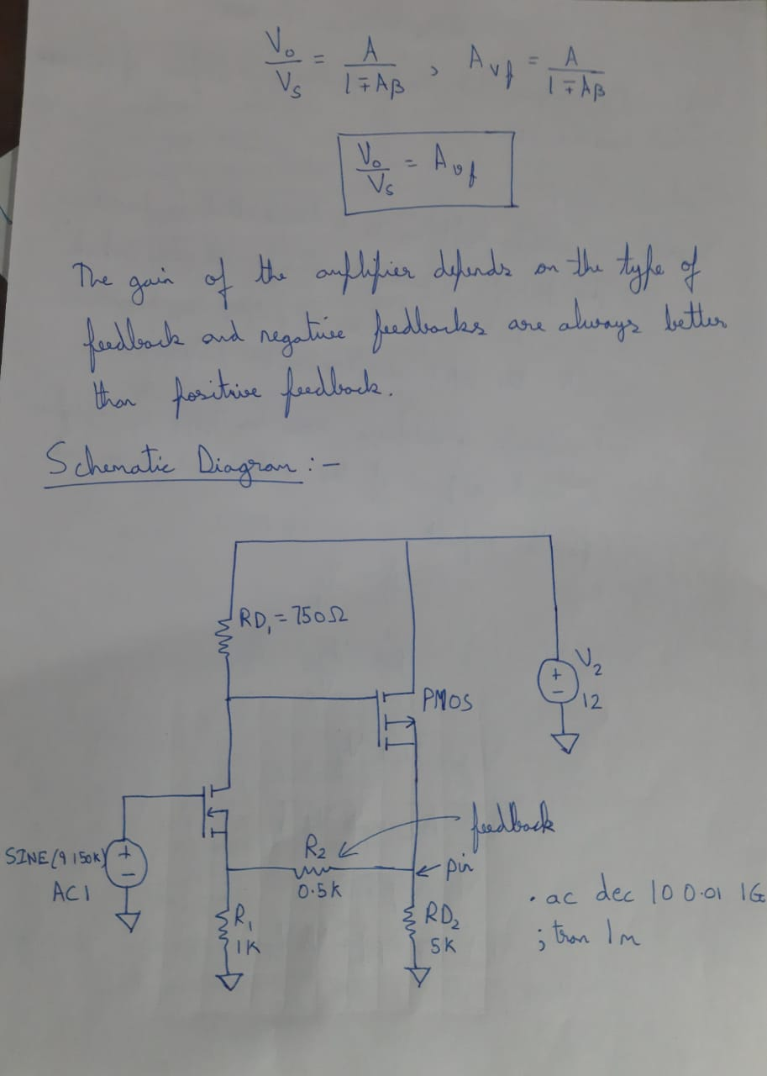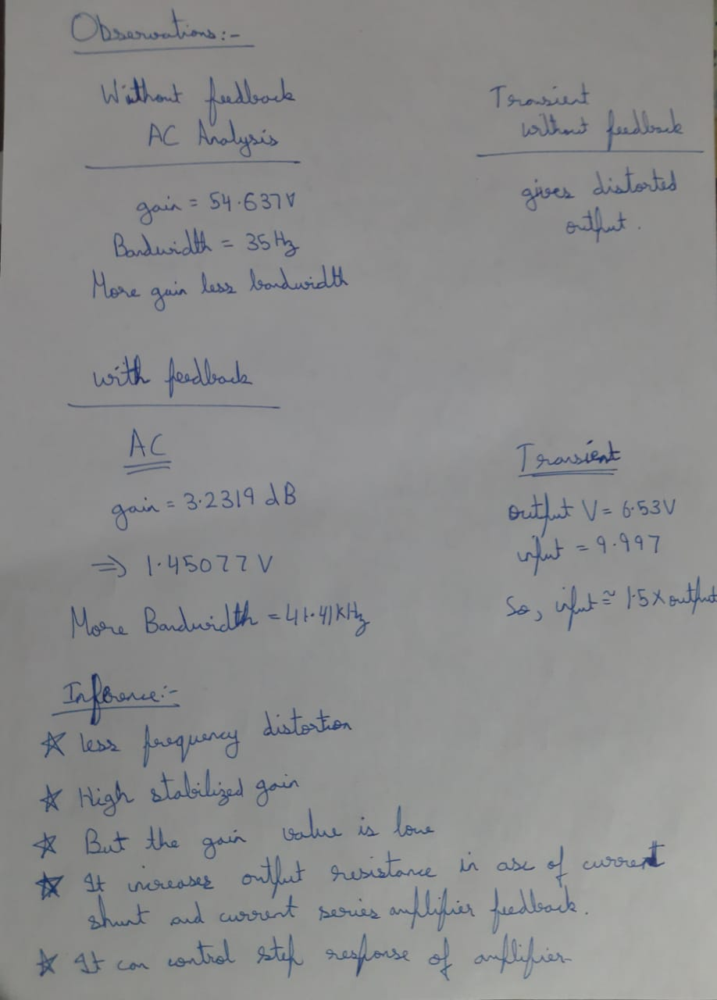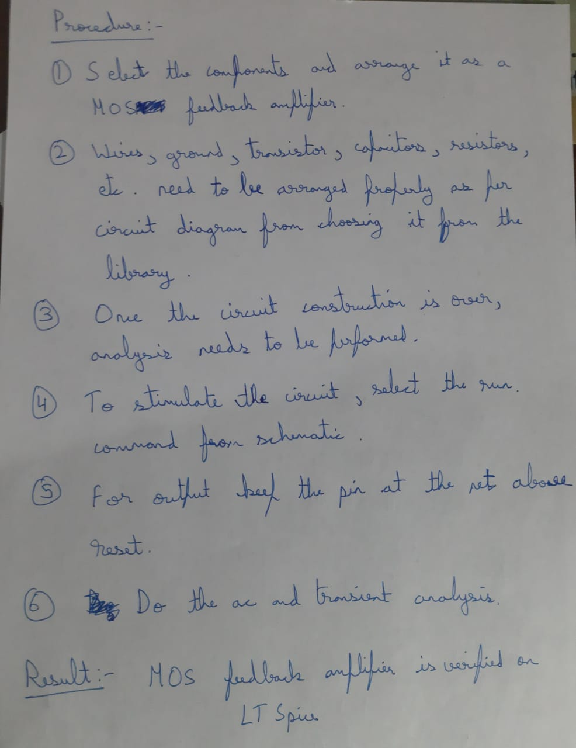

WITHOUT FEEDBACK:

AC ANALYSIS:

TRANSIENT ANALYSIS:

WITH FEEDBACK:

AC-ANALYSIS:

TRANSIENT ANALYSIS:

INPUT:

OUTPUT:

